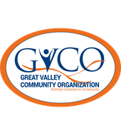
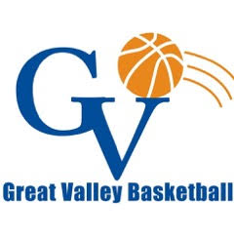

2020-2021 GVCO Banner Sponsorship Program Plan
Goal:
To develop a banner sponsorship program to provide a highly visual marketing opportunity for our sponsors and additional funding for GVCO. The current banner sponsorship plan will be expanded on in the new GVCO building with additional options.

Sponsor Incentives/Sponsor Fee:
Bronze Level $300: Wall Banner (3’x5’), Logo & Link in the bimonthly GVCO newsletter
Silver Level $500 (Best Value): Wall Banner (3’x5’), GVBL Team Shirt Sponsor, Logo & Link in the bimonthly GVCO newsletter, Logo & Link on our basketball home page and in our winter basketball weekly newsletter. Around the Rim is our winter basketball weekly newsletter which highlights Junior Hoopsters, GVBL, GVBL High School League, GVMS & GVHS basketball.

Sponsorship Banner Cost:
A referral plan has been established with NuPrint Solutions for sponsors who need banners printed. Specifics regarding banner dimensions are available upon request.

Banner Marketing Plan:
The GVBL Banner Sponsorship Program will be featured on GVBL News/Updates, GVBL Facebook, GVBL Instagram & GVBL blast emails. It will also be featured on GVCO Facebook, the Business Sponsorships section on the website, & the GVCO bimonthly newsletter. Other GVCO programs that utilize the GVBL Center may also market the plan in their communications and programs.
Banner sponsorships are available for renewal annually and for current season.

